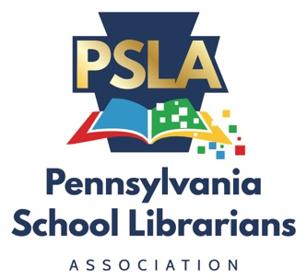 | Pennsylvania School Librarians Association Annual Conference  Annual Business Meeting  Saturday, April 23, 2022  7:30 am – 8:40 am  Hershey Lodge and Convention Center- Red Room

- Call to Order
II. Association Reports
- Secretary’s Report (Elizabeth Henry)
- April 17, 2021 Annual Business Meeting Minutes
B. Treasurer’s Report (Jeff Weiss)
- Fiscal Reports
- Profit/Loss Report
b. Balance Sheet June 30, 2021
III. Committee Reports – Annual
A. Advocacy (Aimee Emerson)
B. Awards (Samantha Hull)
C. Communications (Lauren Strohecker) – Read Only
D. Conference (Mary Schwander)
E. Operations (Caitlin Linsenmann)
F. Teaching and Learning (Leah Lindemann)
IV. PA Department of Education, Office of Commonwealth Libraries Update
V. American Association of School Librarians Update
VI. Old Business
A. Staffing Survey 2021-22 (Aimee Emerson)
B. LSTA Grant Activities Update – 2021-22 (Laura Ward)
C. Other Old Business
VII. New Business
A. Resolutions/ Recognition
B. Bylaws Update
C. Other New Business
VIII. Future Dates
A. ALA Annual Conference - June 23 - 28, 2022 – Washington, D.C.
B. PSLA Summit – July 6, 2022 – Virtual
C. PSLA 49th Conference – March 30 – April 1, 2023 – Harrisburg Hilton
IX. Adjournment

